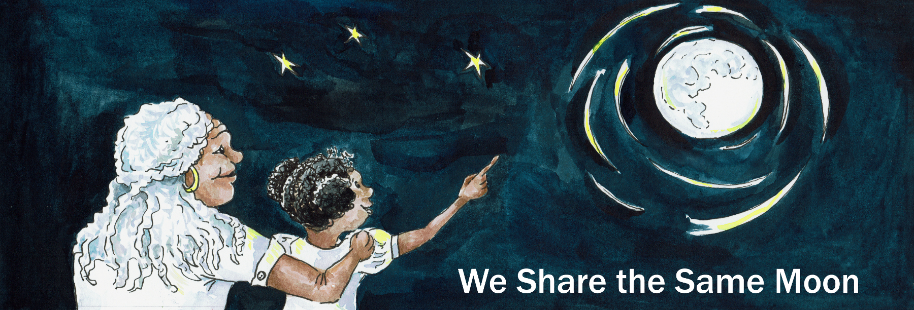
Suggested Age Range: 4 - 5 years; 5 - 6 years; 6 - 7 years; 7 - 8 years
UK Curriculum: Key Stage One
Suggested UK Year Group: Year 1
UK Primary Curriculum Link: Living Things and Their Habitats
Science Subject: Animals
Science Questions: Why do we have day and night?
Why do some animals like the day and some the night?
Suggested Science Activity: Day and Night
Children with SEND: Use to boost comprehension of science vocabulary
EAL children: Beginners Level
Country of Origin: First Nations of America
Source: Tales of the Sun and Moon by Lynn Moroney

Long ago, when the world began, there was no Day and there was no Night,
because, the Sun and the Moon had not yet been created.
There was no light and there was no dark, everything was grey!
Grey, grey, grey, grey, grey!
And it was very difficult to see anything at all!

One day, Rabbit was hopping along and hopping along and hopping along …
And there was a rock in his way! Could he see the rock? No!
And his poor nose hit the rock … PENG! And it was very painful!
“Oo, Ow, Oo, Ow, Oo!” said Rabbit.

The second day, Rabbit was hopping along and hopping along and hopping along …
And then there was a tree in his way! Could rabbit see the tree? No!
And his poor nose hit the tree … PENG! And it was very, very painful!
“Oo, Ow, Oo, Ow, Oo, Ow, Oo!” said Rabbit.

The third day, Rabbit was hopping along and hopping along and hopping along …
And there was a mountain in his way! Could he see the mountain? No!
And his poor nose hit the mountain … PENG! And it was very, very, very painful!
“Oo, Ow, Oo, Ow, Oo, Ow, Oo, Ow, Oooo!” said Rabbit.
“Enough is enough! We need more light!” said Rabbit.

“Oh no we don’t” said a voice above and behind him.
Rabbit turned and peered and saw through the gloom … Owl!

“I can see perfectly well, in the dark!" said Owl.
“We do not need more light. In fact, I say, we need more night!”
‘Oh no we don’t” said Rabbit. Oh yes we do! said Owl.
“Oh no we don’t” said Rabbit. Oh yes we do! said Owl.

"Oh no we don’t!” “Oh yes we do!”
"Oh no we don’t!” “Oh yes we do!”
"Oh no we don’t!” “Oh yes we do!”

And they argued and argued and argued and argued.

Until Rabbit said: “Right, I will call a council of all my friends and we will show you that we need more light.”
“And I” said Owl “Will call a council of all my friends and we will show you that we need more night!

So Rabbit and Owl brought all their friends together.

Rabbit spoke first: “Friends, I have brought you here today to discuss whether we need more light or more night. Who agrees with me, that we need more light?”

“I do” said Robin “ I need more light to find twigs for my nest. My nest has so many holes in it, all my eggs fall through to the ground. So, I say, we need more light!”

“Well - I disagree” said Bear “I say, we need more night. Because, we bears need a lot of sleep and we need darkness to get to sleep. I agree with Owl - we need more night!”

"Oh no we don’t!” “Oh yes we do!” "Oh no we don’t!” “Oh yes we do!”
"Oh no we don’t!” “Oh yes we do!” "Oh no we don’t!” “Oh yes we do!”

And they argued and argued and argued and argued

Until Rabbit said: “Right, we shall have a competition!”
Those of us who want more light shall chant for “Light”
Those of us who want more night shall chant for “Night”
And so they began.

All the day-time animals they chanted:

Light, light, light, light,
Light, light, light, light,
Light, light, light, light,
Light, light, light, light.

And all the day-time animals, they chanted:

Night, night, night, night,
Night, night, night, night,
Night, night, night, night,
Night, night, night, night

And so the competition began:

Light, light, light, light! Night, night, night, night!
Light, light, light, light! Night, night, night, night!
Light, light, light, light! Night, night, night, night!
Light, light, light, light! Night, night, night, night!

“Stop!” said Rabbit “Stop! Why are we arguing?”“Why don’t we share?”

“Half the time shall be light for those of us who like the light,
and half the time shall be night for those of us who like night!”

And everyone agreed.

And with that, there was a flash of light - whoosh!
And the Sun rose in the Sky to give light to the daytime animals.

And then, when the Sun sank and the day-time animals went to sleep,
there was another flash - whoosh!
And the Moon appeared to give light to all the night-time animals.

And so there was just enough light for everyone.
And so they lived, happily ever after.

But - is this true?
Scientists say that it is because the Earth spins in the Sky,
but the Sun stays still, that we have both day and night.

But - what do YOU think is true?

Copyright: Cassandra Wye, May 2019

